# **Abstract:**

since 1970, Around more than 2,00,000 international and domestic terrorist attacks are happened according to our global terrorism database.The GTD defines terrorist attacks as: actual use of illegal force and violence to attain their demands through fear, coercion, or intimidation.

Our EDA can make us understand about the terrorist activitys among the country, state, regions etc. we will also know about the reasons behind the attacks & group related informations.

# **1. Problem statement:**

The database— contains information on multiple dimensions of each event. Many structured variables characterize each attack’s location, tactics and weapons, targets, perpetrators, casualties and consequences, and

general information such as definitional criteria and links between coordinated

attacks. Unstructured variables include summary descriptions of the attacks and more detailed information on the weapons used, specific motives of the attackers, property damage, and ransom demands (where applicable).

The main objective is to do Exploratory Data Analysis(EDA) on the dataset which was provided, to conclude the facts about the certain features which are mentioned.

* **Years:** it contain list of years in which the terrorist activity happened.
* **Country name:** It’s contain list of countries those are affected by terrorism.
* **Regions:** Its hold the information of name of the region’s affected by terrorist
* **Attack_Type:** This column is related with the attack type such as bombing/explosion, hostagetaking(kidnapping), hijacking & etc.
* **Main_target:** Its hold the information of the main targets of terrorist.
* **Killed:** This column hold the information of the killed people by the terrorists.
* **Gang_Name:** this column gives the information of the terrorist’s gang name.

**2. Steps involved:**

* **Data Wrangling:**

After loading the dataset we performed this method by cleaning, organizing, and transforming raw data into the desired format which makes us understand the data clearly. This process helped us to tackle the unwanted data, to produce accurate results, and to make better decisions.

* **Null Value Treatment:**

Our data set contains some null values; still we have treated the null values by filling with zeros in order to produce more accurate results.

* **Creating Dataframe:**

We tried to reduce the data frame. This is because there were a lot of columns which were just taking up space in the dataframe which meant we could not do any analysis based on it and I think this type of data would confuse us every time so we only Created a new dataframe with only those columns that contained important and useful information and based on which we could perform any kind of analysis.

* **Exploratory Data Analysis (EDA):**

After the data wrangling and other steps we performed EDA by comparing different parameters which are involved in the dataset. EDA helps us to find the different relations among the parameters. It involves the visualization of the data by comparing the different parameters to find out the best among all.

**3. EDA:**

In the process of understanding the data we found that **attack type, main target, country name, gang name & year** are the some most important parameters in global terrorism . So we performed an analysis based on **attack type, main target, country name, gang name & year** and some other types of analysis are present in our ppt & notebook.

We figured out the total of each number of attack type , it help us to know which type of attacks used most by the terrorists during his terrorist activitys, according to our analysis **‘Bombing/Explosion’** is mostly used by the terrorists followed by **‘Armed assault’, ‘Assassination’** etc

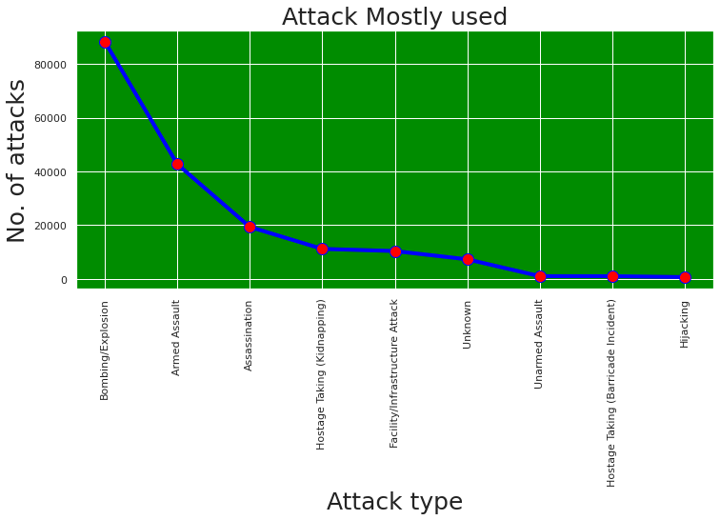

After this we focused on some points:  
1. which countries are mostly affected by terrorist.

2. What is the main target/purpose of terrorist behind the attacks.

3. Which group carried out the most attacks in which year.

So basically according to the analysis **‘Iraq’** is the country which is most targeted by the terrorists followed by **‘Pakistan’** , **‘Afghanistan’**.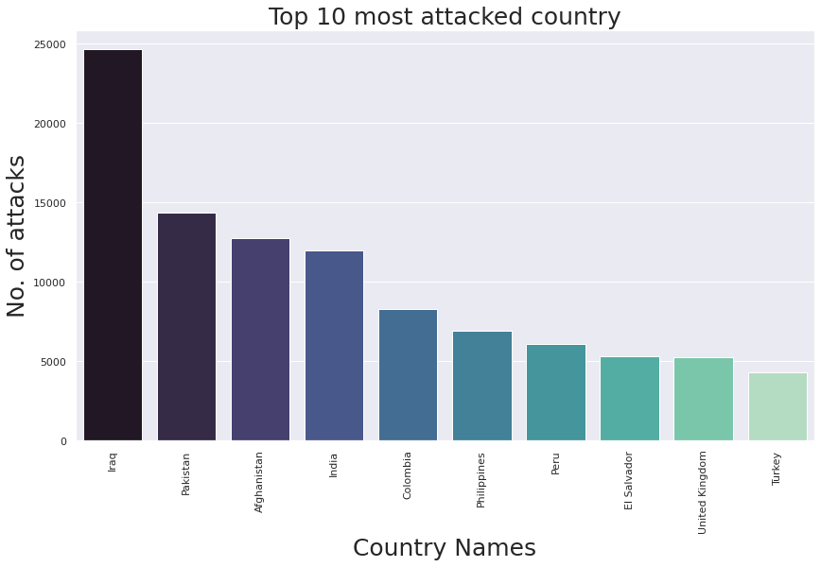

Now, According to analysis we seen that the main targets of terrorist are **‘private citizens and property’** followed by **‘military’**, **‘Police’** & **‘Government’**.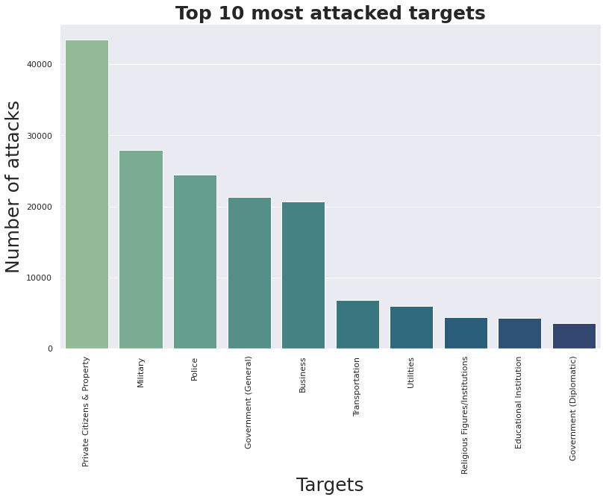

So now the third point is information about groups and years .

According to analysis **‘Taliban’** is the the gang which have the most number of attacks in all of them followed by **‘Islamic state of iraq and the levant(ISIL)’** & **‘Shining path’.**

After 2011 we can see that there is a large growth recorded in terrorist attack.

Then 2014 appears to be witness of a huge terrorist attack.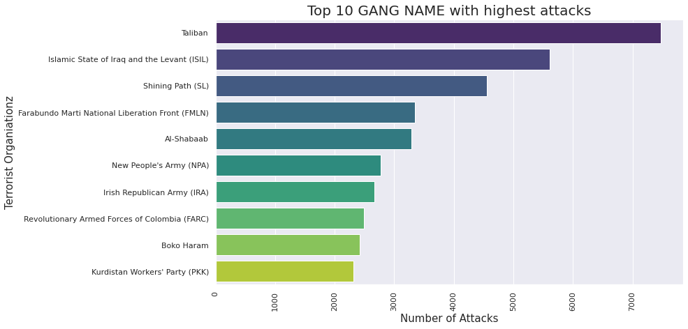

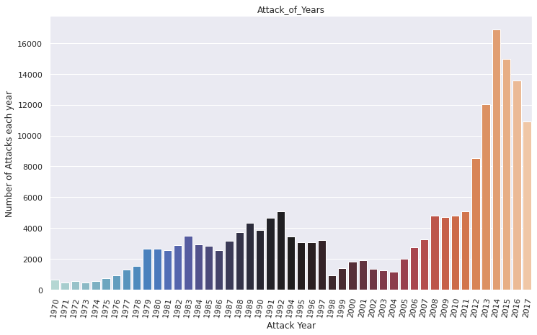

**Conclusion:**

After loading the data as the first step, we have performed data wrangling, null value treatment and EDA. Here we found that there are very few columns which have null values in the data wrangling step.

In the EDA we have conclude that after 2011 there is a large growth recorded in terrorist activitys and 2014 appears to be a witness of huge terrorist attack this is also almost same for next years. We also seen that most of attack is hapeened wih the help of ‘Bombing/Explosion’ approx(50%).

According to the research ‘Iraq’ is the most affected country by terrorist and most of the targets of terrorist’s are private citizens and property which is followed by military, police & etc.

# 